HCIN6222

 |

HCIN6222 POE Part 1

Keoagile Mafora

2025

Contents

What am I doing? 2

Introduction 2

Functionality 2

Usability Goals 6

How am I going to make it Effective to use: 6

How am I going to make it efficient to use: 7

How am I going to make it safe to use: 7

How am I going to have good utility: 8

How am I going to make it easy to learn: 8

How am I going to make it easy to remember: 8

Desirable aspect of user experience 8

Design Principles 11

Interaction Types 11

Social Interaction 12

Being Social 13

Face-to-Face Conversations 13

Remote Conversations 13

Emotional Interaction 13

Key Points of Emotional Interaction 13

Application of Emotional Interaction 14

Web Content Accessibility and Guidelines (WCAG) 2.0 14

Perceivable 14

Operable 15

Understandable 15

Robust 15

References 15

# What am I doing?

I’m creating website that is going to track your assignment and is going to notify you when there is something you need to submit, there’s going to be a calendar that will show all the dates and what is due when so that when you open the app there’s a reminder that the student needs to be ready for the assignment or tests.

# Introduction

This assignment shows how I planned and designed the web application that tracks assignments of students. This website will help students with managing deadlines, receiving reminders of the assignments, and improve productivity of the students by having features such as calendars, notifications, and progress tracking of the assignments. In this document, I will be explaining the website’s functionalities, the usability goals, the user experience aspects, the design principles, the interaction types, and the social and emotional interactions that are added into the system. The users will manually insert which modules they are doing and when they will need the reminders for the assignments that are due.

# Functionality

When a student visits the website, they see a homepage that gives the user an option to register or log in.

1. If the user is new to the website, the user must click the register button, they must provide their names, their students email, and the password that they are going to use when using the website. The website will confirm that the registration is good by redirecting the user to the login page. 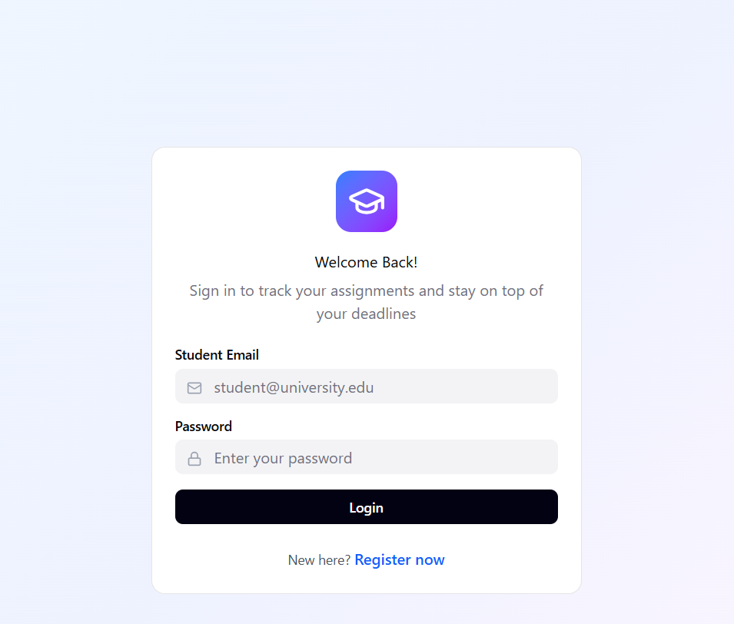A screenshot of a login form

   AI-generated content may be incorrect.  
     
   A screenshot of a login form

   AI-generated content may be incorrect.
2. Then if the user has already registered, the user will login then it will go automatically to the dashboard. At the top of the dashboard, the student will see the date, and on the side, there will be a list of the tasks.  
   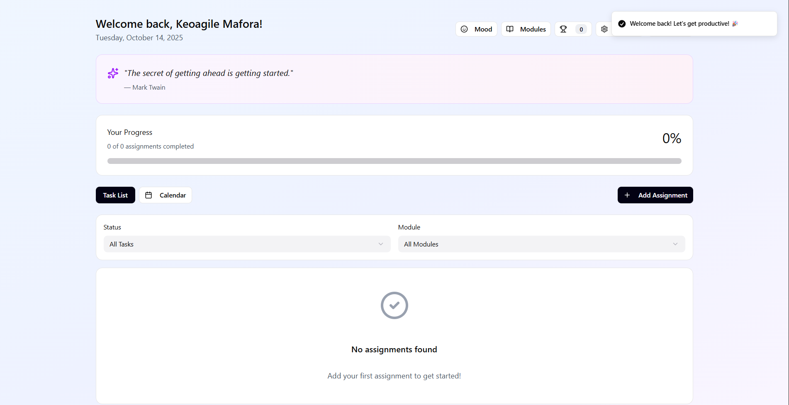
3. When the student wants to add the first task, they will click the “Add Assignment” button . Then the student will see a form where they can enter the title, the dropdown of the module, the due date, and the reminder time. Once the student saves, the assignment will be shown on the dashboard on the task list.  
   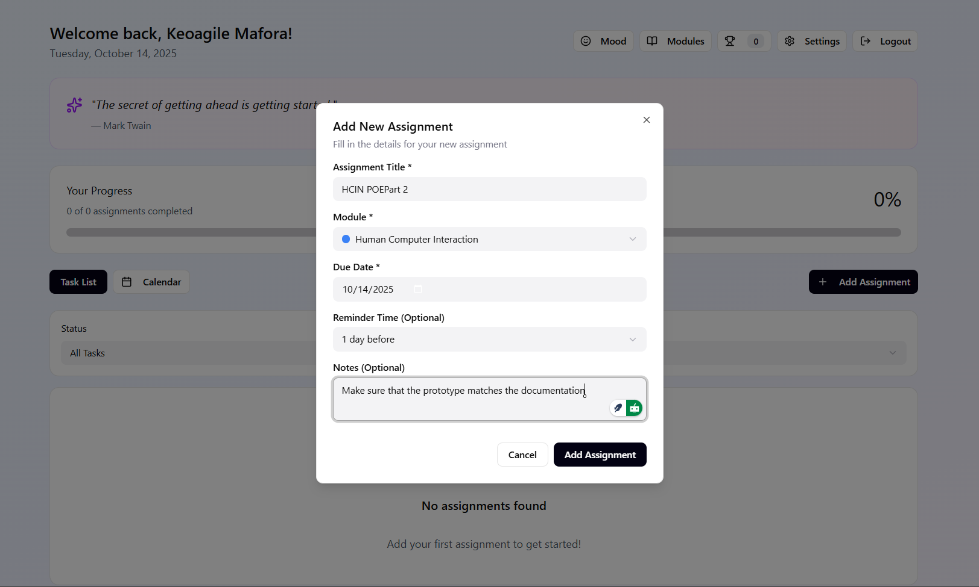
4. As the deadline approaches, the system will send the user a notification, not outside of the website, when using the website. This will help the students stay on track with the tasks without having to check the tasks constantly.  
   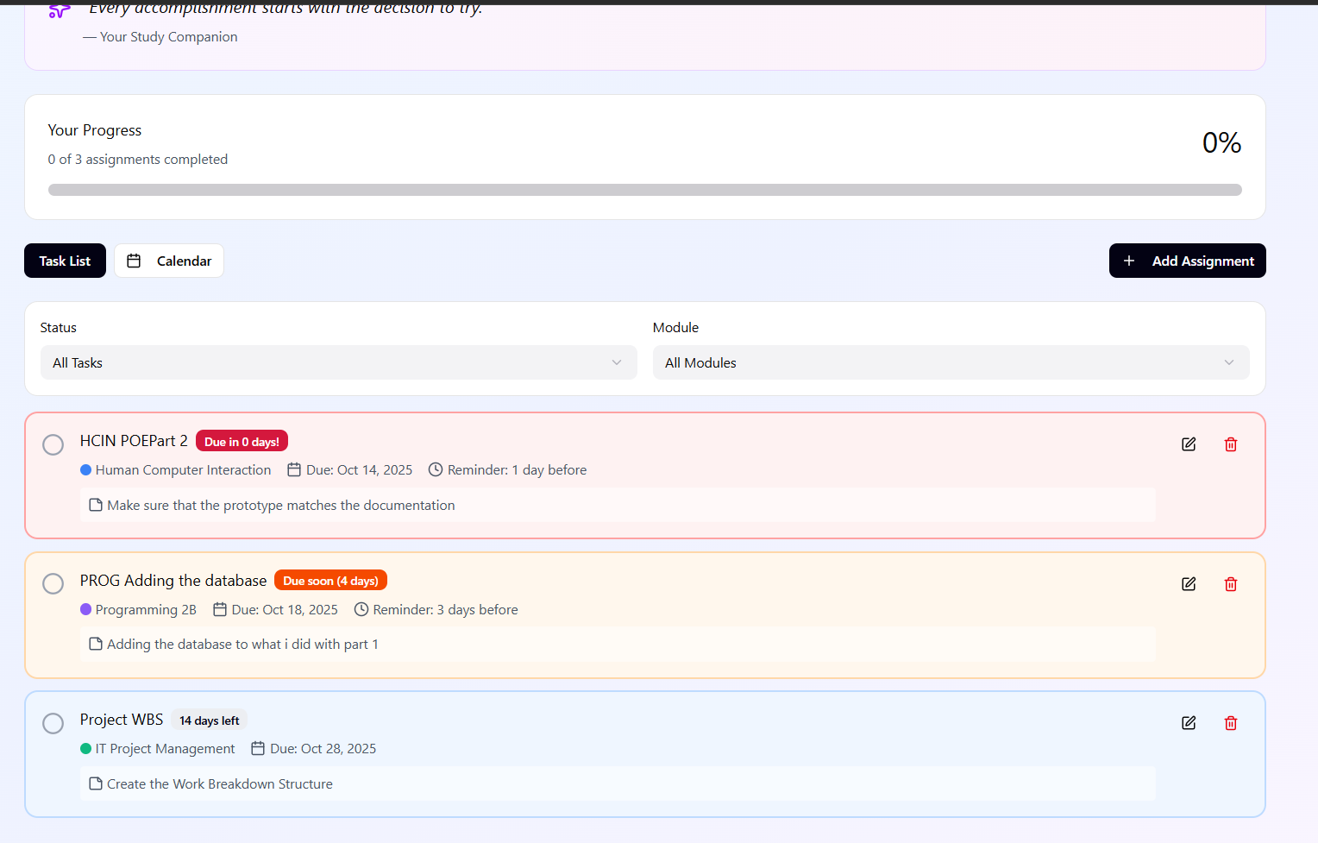
5. When the student finishes the assignment, the student will return to the dashboard and click the “Mark as Completed”. The task will turn green, meaning the progress bar will be updated. Showing the user that it’s an achievement.  
   A screenshot of a chat

   AI-generated content may be incorrect.
6. If the user needs to edit a task, the student will simply click on the task in the calendar, they can update the details and save the tasks. If the user wants to delete it, the system will ask the user to confirm so that there are no mistakes.  
     
   A screenshot of a computer

   AI-generated content may be incorrect.
7. The student can browse the calendar to see all the upcoming assignments by a certain module, and the student can filter them based on the due date and the completion status.  
   A screenshot of a calendar

   AI-generated content may be incorrect.
8. When the student is done using the website, they can click the Log Out button, then the system closes.  
   A screenshot of a computer

   AI-generated content may be incorrect.

# Usability Goals

## How am I going to make it Effective to use:

* I’m going to make sure that the users can clearly see their upcoming tests, assignments or exams with their deadlines. I’m going to make sure that there is color co-ordination to the tasks that are needed meaning there will be colors such as green - done, blue – still have time, and red – which is due soon(This will be red in the last days), this will make it easy for the user to see that they have completed or could not meet the deadlines.   
  A screenshot of a computer program

  AI-generated content may be incorrect.  
  I’m going to make sure that there is a confirmation message after every action such as (“The task is done”), for the user to know that they have completed the task on time.  
  A screenshot of a phone

  AI-generated content may be incorrect.

## How am I going to make it efficient to use:

* Since I’m making it for my peers, I’m going to add modules that we are using in our 2nd year, but the user can add the modules. So that the users can be comfortable with the colors they have chosen, this will help the user to be on the website more due to the colors  
  A screenshot of a computer

  AI-generated content may be incorrect.  
  Adding a calendar tap to add reminders so that the users don’t type manually the date of the due date. I’m going to make sure that every page has own function and can be accessed with its own buttons so that the user does not have to search on their own.

## How am I going to make it safe to use:

* I’m going to add safety precautions such as an undo option so that when the user makes a mistake when creating a task meaning they will easily use the website. Including a login system that has a username and password so that there can be protection of sensitive information. Adding an option to confirm if the user is sure about the actions that they are doing.  
  A screenshot of a login form

  AI-generated content may be incorrect.

## How am I going to have good utility:

* I’m going to make sure that there will be notifications when there is a deadline approaching, this will also include the colors in the calendar to show that deadlines are on the way. There will be a text block where you will be able to write any notes that you will need when completing that assignment.  
  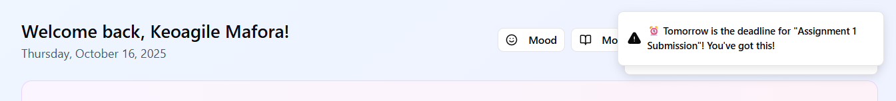

## How am I going to make it easy to learn:

* By adding simple icons and simple English in the buttons so that the users can use the application easily.  
    
  A screenshot of a computer

  AI-generated content may be incorrect.

## How am I going to make it easy to remember:

* I’m going to make sure that it is going to remain the same the whole time, I’m going to use similar icons to most popular website so that it is easy to use and remember.  
  A screenshot of a computer

  AI-generated content may be incorrect.

# Desirable aspect of user experience

* Satisfying: I will be adding a progress bar so that when the user finishes their assignments or any tasks, the users can be satisfied with their progress of finishing tasks.  
  A white rectangular object with black lines

  AI-generated content may be incorrect.
* Enjoyable: The users can choose their desirable colors, and the colors they are comfortable with.  
  A screenshot of a computer

  AI-generated content may be incorrect.
* Exciting: There are achievements when users are finished with a certain number of certain tasks.  
  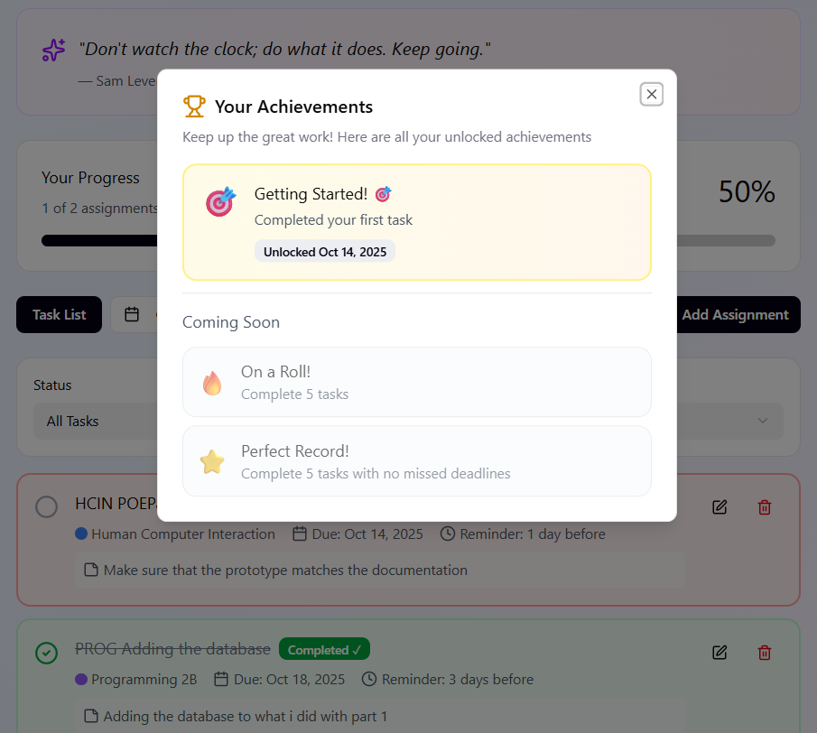
* Entertaining: Adding productivity quotes when the user either finishes the tasks or when they couldn’t finish a task. When a user finishes the work , there will be words of affirmation whether they are done with the assignments, or they fail to meet the deadlines, like the picture below.  
  A close-up of a white background

  AI-generated content may be incorrect.
* Helpful: When there is an assignment being submitted in a day, the user is going to be notified that they should start or just be notified that there’s is an upcoming assignment.  
  A screenshot of a computer

  AI-generated content may be incorrect.
* Enhancing sociability: Adding an option to share the users’ progress of the finished tasks with their peers.  
  A screenshot of a computer

  AI-generated content may be incorrect.
* Supporting creativity: Adding an option for the user to customize their calendar.  
  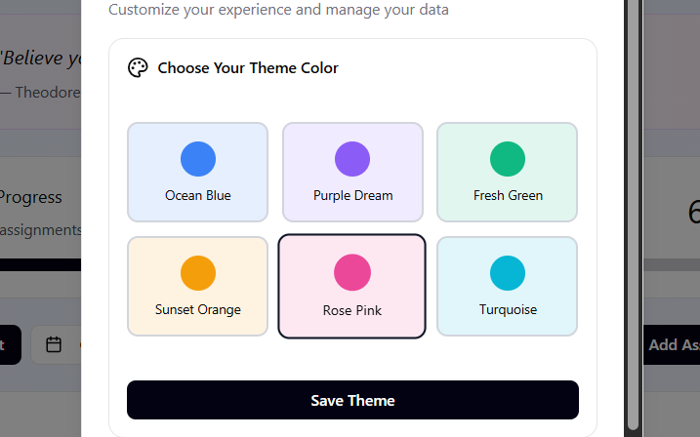
* Fun: Having a friendly tone when there is any pop up in the application, for example, “Well done!!!”.  
  A screenshot of a phone

  AI-generated content may be incorrect.
* Rewarding: Adding virtual awards, such as certificates for every task done.  
  A screenshot of a computer

  AI-generated content may be incorrect.
* Emotional Fulfilling: When the user hasn’t missed 5 or more deadlines, they will receive a milestone.

# Design Principles

* **Visibility:** Making things such as deadlines and the upcoming tasks in the coming weeks to be more visible and are shown easily or are shown immediately when opening the application. Like in the dashboard shown below.
* A screenshot of a computer

  AI-generated content may be incorrect.
* **Feedback:** Adding information back to the user to confirm what has happened or what has happened in the system. For example, “The Module is successfully added”.  
  **A white and black sign with black text

  AI-generated content may be incorrect.**
* **Constraints:** Restricting the user from adding actions that cannot be performed, this is going to help the user not to select incorrect things such as. For example, the user will not be able to enter the date from the past.
* **Consistency:** I will be adding buttons that are similar so that there is consistency and the user does not get confused. For example, Using the icon of the plus(+) sign as a button to “Add module” or “Add modules”.  
  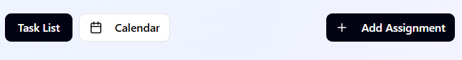  
  **A black rectangular sign with white text

  AI-generated content may be incorrect.**
* **Affordance:** Making sure that the user does not guess which buttons are clickable, and show that the calendars are interactive

# Interaction Types

* **Instructing:** This is what the user will be wanting the system to do. On the website the user will instruct the website to add an assignment or a new module, and they will confirm by clicking th “Add Module”, for example:  
  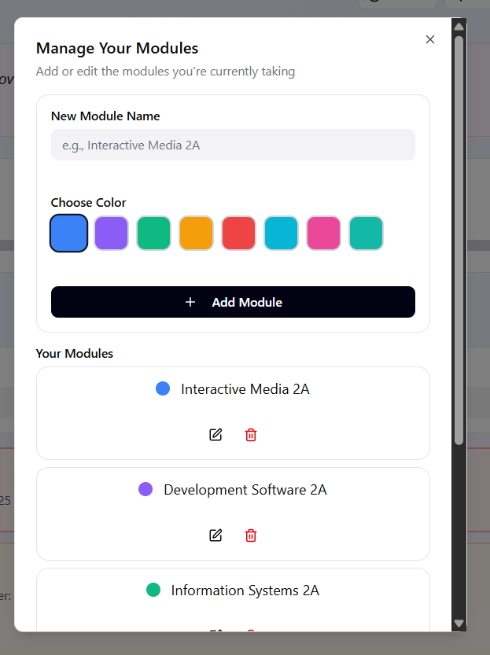
* **Conversing:** This is where the user will be able to conversate with the system via text. For example, when the user asks the system to remind them to do the task the next day.
* **Manipulating:** The users will be able to interact with virtual objects and manipulate them. For example, the user is going to be able to change the date of the due date when there is a change in the submission dates. Like the example shown below.  
  A screenshot of a computer

  AI-generated content may be incorrect.
* **Exploring:** This is when the users can move around virtual space. For example, the users can decide to browse through the calendar or navigate the module list to find if there are any tasks.
* **Responding:** When the system initiates the interaction and the user chooses whether they want to respond or not, I am going to implement this by adding a pop-up notification every time the user enters a task or when there is a task that is due tomorrow the user can choose to snooze it or just click okay.

# Social Interaction

Social Interaction is all about how the website supports, and transforms the way people communicate, collaborate, and coordinate with each other using the website. The website will allow students to be:

## Being Social

* The system should allow the users to be able to interact with other users.
* For example, other students should be able to see their friend’s progress of the assignments or submissions only when it is shared. Also adding features such as “Group reminders”, where the peers will be able to remind each other on the work that they need to do.

## Face-to-Face Conversations

* Face-to-Face Interactions mostly include naturally seeing a person using eye contact, and gestures such as nodding.
* When the students use the website on a group study setting, they will be able to share on a projector, so that they can discuss the work while using the same calendar.

## Remote Conversations

* Remote conversations allow people to communicate when they are not located in the same area, for example, emails and chatting.
* For example, when students are working on the same assignment, they can remotely share that the deadline is on the way using the notifications. A chat panel where students will be able to comment on the tasks so that they can have a back and forth of conversations.
* 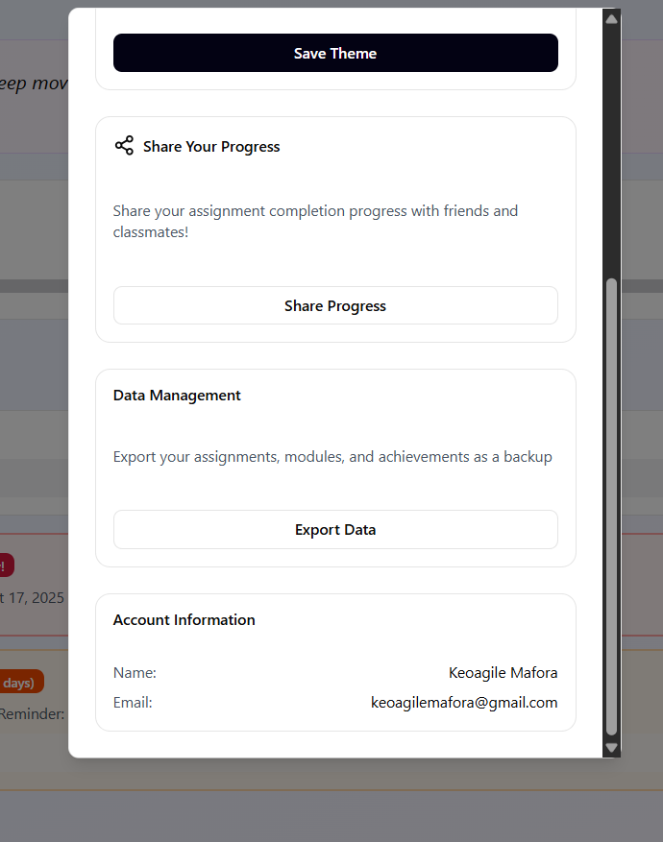

# Emotional Interaction

Emotional interaction is about how the user is feeling when using the website which can influence how they interact with the website, and how the system can support how the user feels and respond to how the user is feeling.

## Key Points of Emotional Interaction

* Positive emotions can improve how the user is learning and problem solving of the website. Also, when the users are having negative feelings, they can end up quitting
* When designing the website, I will be designing so that it evokes positive emotions, meaning it will be enjoyable, and motivating. For example, when they meet the deadline, the system will say something playful and visually appealing popouts.
* Having an expressive interface when the user does anything within the website, for example, when the user fails to meet the deadline there will be colors that and a text that will motivate the user that it’s okay to fail to meet the deadlines but to never give up.
* The system can give the students some motivation when there is a deadline coming so that they can focus on the coming assignment, for example, cheering (“You can do it!!!”) for the user when entering the system so that they don’t give up on the assignment.
* There are different cultures, and they all express their emotions differently meaning it must make sure that it accommodates all the cultures so that it can interpret the emotions easily and no one gets offended.

## Application of Emotional Interaction

* The website will not be for any formal company meaning it has to accommodate the students meaning having an error message such as “Invalid Input”, we will say “Oops, this date has passed please try another date!”.
* When tasks are complete the website should be able to have a congratulations animation, for example, “Amazing work, you finished your second assignment this week!!!”.
* The system will allow the user to enter an emoji to show the system how they are feeling that day, for example the user can put this emoji “😔” the website should be able to give the user a tip or motivation so that they can feel better.

# Web Content Accessibility and Guidelines (WCAG) 2.0

According to the W3C(2025), WCAG 2.0 is built on four core principles which are

## Perceivable

* The information on the website and the User Interface must be presented in ways that can perceive the user, which is to see, to hear, and to feel.
* For example, having a color contrast between the text and the background of the website, and having alternatives of text to a non-text, meaning we can use emojis so that the website feels good to use. Like the picture shown below
* 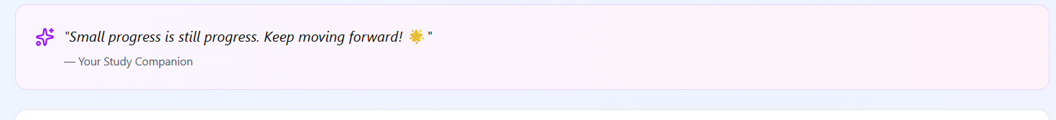

## Operable

* The User Interface components and the navigations must be usable in multiple ways, meaning there shouldn’t only be mouse action, the student must be able to use the keyboard.
* For example, all the functions must be available from the keyboard meaning there shouldn’t only be mouse action only. I’m going to make sure that the designs do not cause the users to have seizures, meaning there shouldn’t be any flashing content.

## Understandable

* Information shown on the website must be clear and consistent.
* For example, having simple and readable language, I’m going to also add a navigation that is predictable for the user to use. It is going to be implemented by adding a feature of when I double click a date you can add an assignment.

## Robust

* Content must be usable with current technologies and future technologies.
* For example, I am going to be using HTML code so that it is on the website.

# References

(W3C), W. W. W. C., 2025. *Web Content Accessibility Guidelines (WCAG) 2.1.* [Online]   
Available at: https://www.w3.org/TR/WCAG21/  
[Accessed 22 September 2025].

Sharp, H., Rogers, Y. & Preece, J., 2019. *Beyond Human-Computer Interaction.* 5th ed. Indiana: John Wiley and Sons, Inc.